Case Study

IT and Database Consulting Services for GOVGISTICS : Managing 5K New Gov.’t Contracts Daily

Executive Summary

The GovGistics product is a comprehensive single source Government Research and Solicitation Monitoring Tool that delivers RFQ and RFP opportunities from the DoD and other sources to its customers as well as provides access to a complete NSN Database and procurement history which covers DoD, GSA, Emall and more. By using GovGistics, government contractors can more effectively streamline the process of researching, finding and winning DoD contract awards.

GovGistics engaged EndPointConsulting (EPC) to build a robust and scalable backend system to crawl thousands of government documents daily and present the information in an organized manner to GovGistics customers.

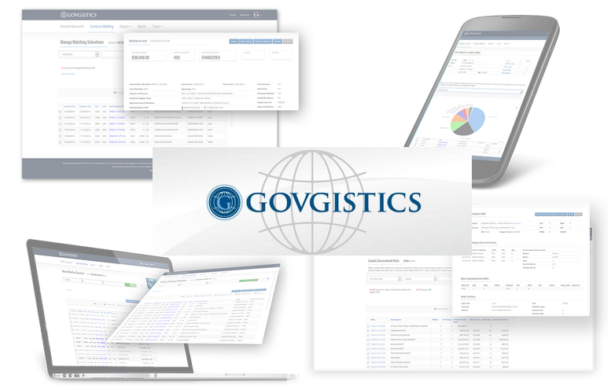

Technologies involved:

* Microsoft SQL Server
* Microsoft .NET Framework
* Custom Spider Development
* HTML5
* ANGULARJS
* NODE.JS
* Web API

Challenges

Previously written codebase were relying on very outdated technologies, such as SQL Server 2000 & Visual Basic. Web crawlers (spiders) were poorly written and presented huge maintenance challenges, which produced consistent defects that needed to be addressed. Furthermore, the database structure was designed inefficiently, which led to extremely poor performance.

How Services Helped

EPC provided the necessary offshore database and IT talent to help Govgistics re-write the existing software, as well as create brand-new subsystems to help streamline their business processes. EPC consultants created innovative ways to load and process data from antiquated government data sources into the Govgistics relational database.

Results, Return on Investment and Future Plans

Currently EPC has a team of 3 consultants servicing the needs to Govgistics full-time. The consultants are located offshore in the EPC Minsk office in addition to a database architect placed full-time in the Govgistics office. Govgistics has been able to return to profitability and increase sales by 300% since EPC began its engagement with Govgistics.